**Input File:**

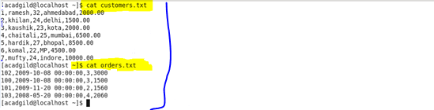

**Join:**

**C:\Users\612926\Desktop\2.png**

**Output:**

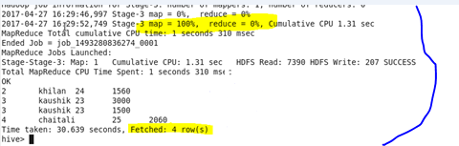

**Left Outer Join :**

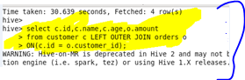

**Output:**

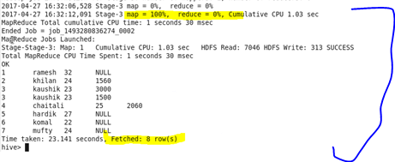

**Right Outer Join:**

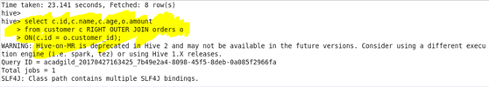

**Output :**

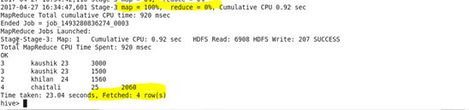

**Full Outer Join:**

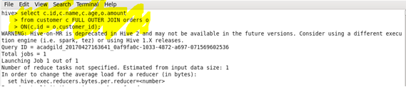

**Output :**

